cd /u01/appl/oracle/product/19.0.0/dbhome_1
./runInstaller
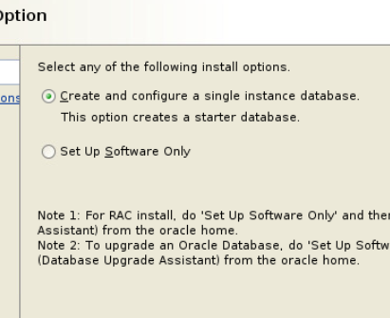
Prva moznost vytovry db server
druha iba db instanciu
Soft only
Next
Enterprice edition
Next
Inventory: 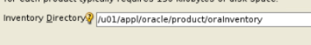
Next
Next

Fix all -> copy command root do noveho terminal paste
Done a ignore a zas next a install
Vykoname skripty kt nas to pita, a bude close

To bolo bez db trz s db
cd /u01/appl/oracle/product/19.0.0/dbhome_1
./runInstaller
1va moznost next
Desktop class next
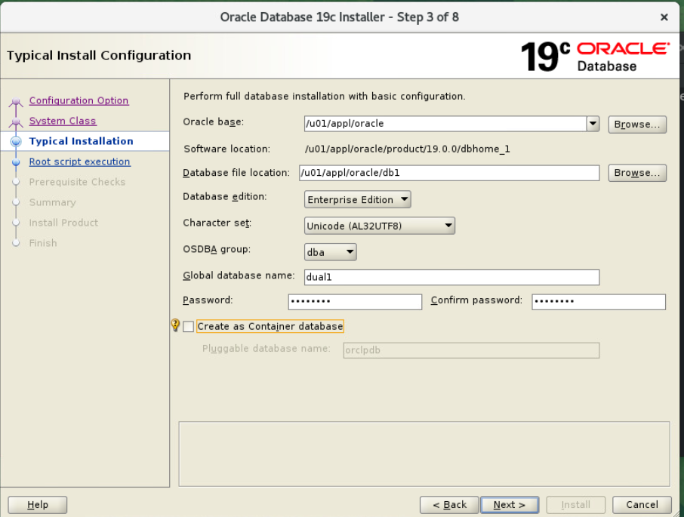next
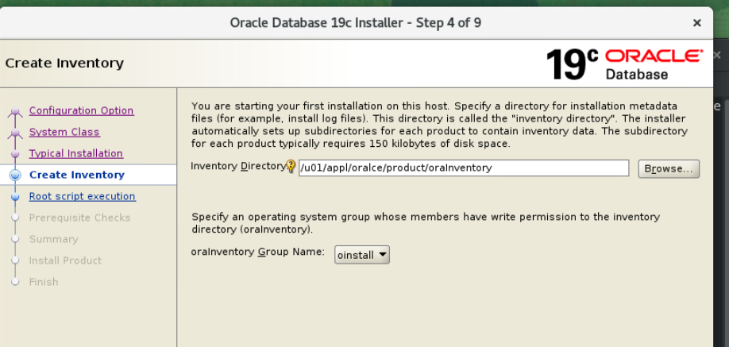next
Spravime install a skripty co nas pita a otvorime novy user a dame
. raenv
Tam do toho: dual1
A nasledne ideme do sql
sqlplus / as sysdba

23.10
Cd /u01/appl/oracle/product/19.0.0/dbhome_1/install/response
Pouzivane ked instalujeme viacero rovnakych db iba iny id

Tam spravime kopiu a upravime subor
Oracle.install.option=INSTALL_DB_AND_CONFIG
UNIX_GROUP_NAME=dba
INVENTORY_LOCATION=/u01/appl/oracle/product/oraInventory
ORACLE_HOME=/u01/appl/oracle/product/19.0.0/dbhome_1
ORACLE_BASE=/u01/appl/oracle
Oracle.install.db.InstallEdition=EE
Oracle.install.db.OSDBA_GROUP=dba
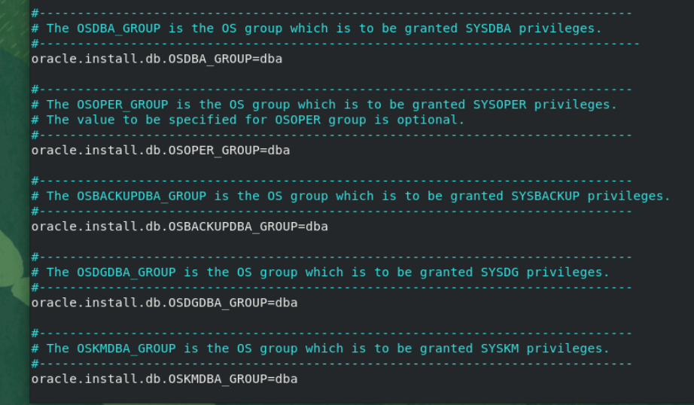
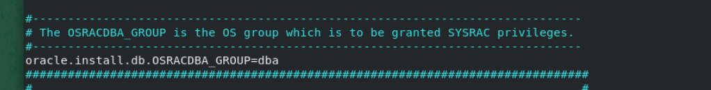
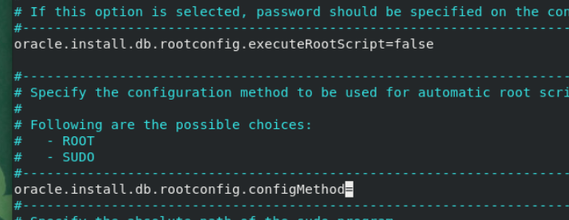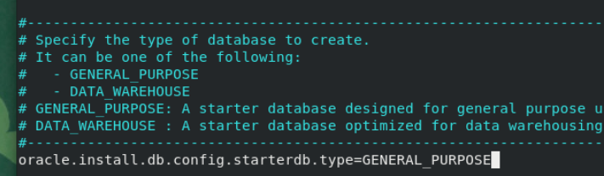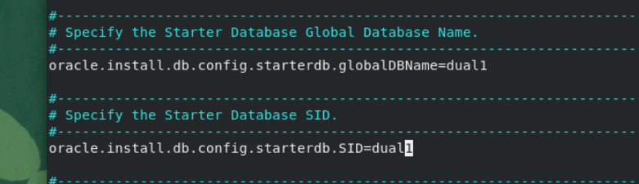
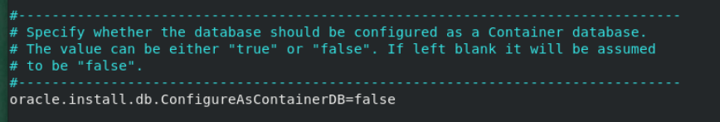
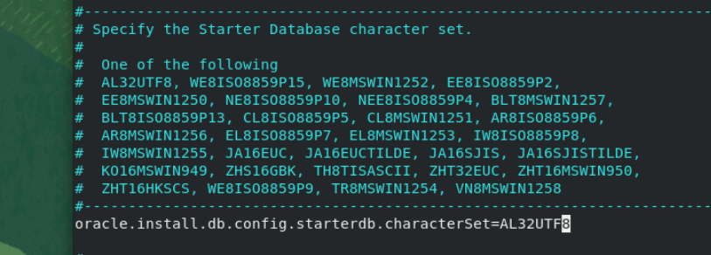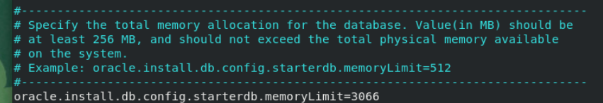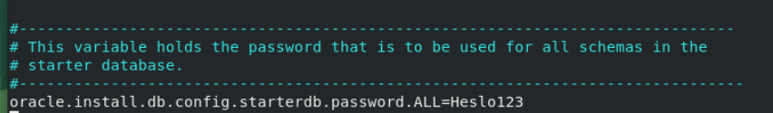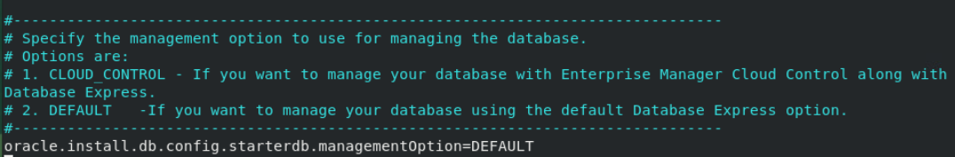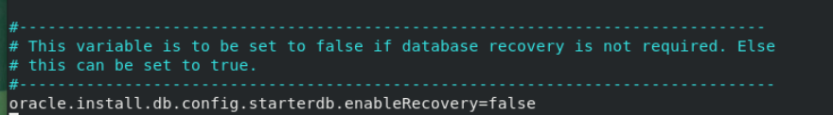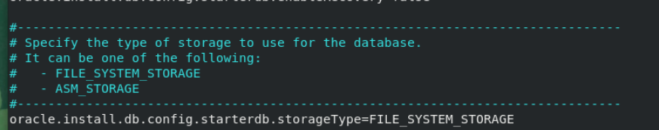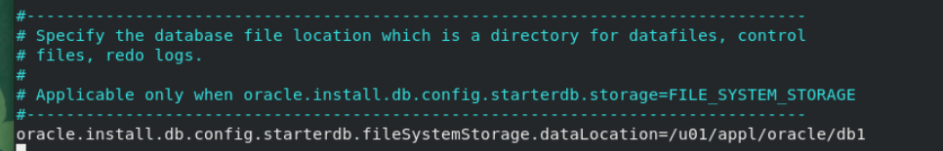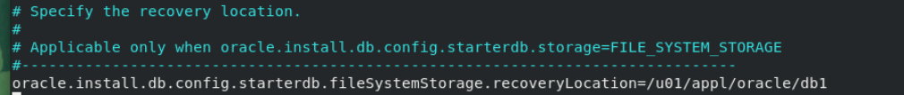
Ulozime a toto runneme
Skontrolujeme file s errormy ak vsetko ok dame

